User Manual
Outlook Add-in Group Policy



With This Manual You Will Learn
With This Manual You Will Learn 2
Control SpecterX Outlook Add-in using GPO 3
Creating a Group Policy Object 3
Configure registry perferenes to enable/disable SpecterX outlook add-in 4

Control SpecterX Outlook Add-in using GPO
Important Note: Use group policy management with caution! Always associate the group policy to a small group of users/endpoints before making a broad domain-wide change.

Creating a Group Policy Object
- Open Group Policy Management Management Console
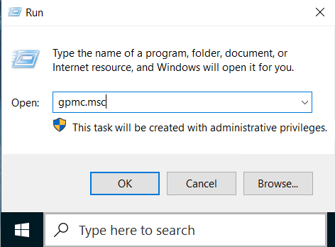
- Create a new Group policy object.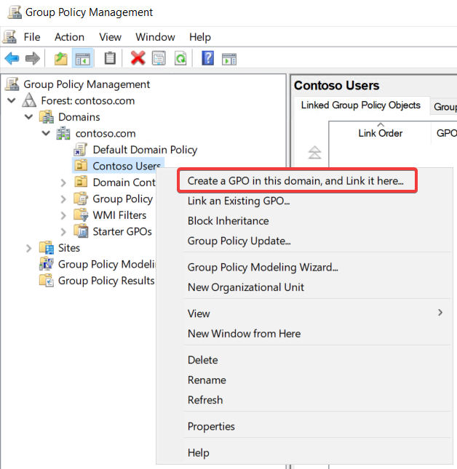

- Provide a name for the new group policy object: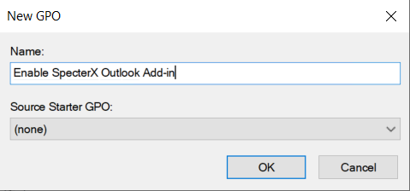

Configure registry perferenes to enable/disable SpecterX outlook add-in
- Right click the newly created group policy object and select ‘Edit’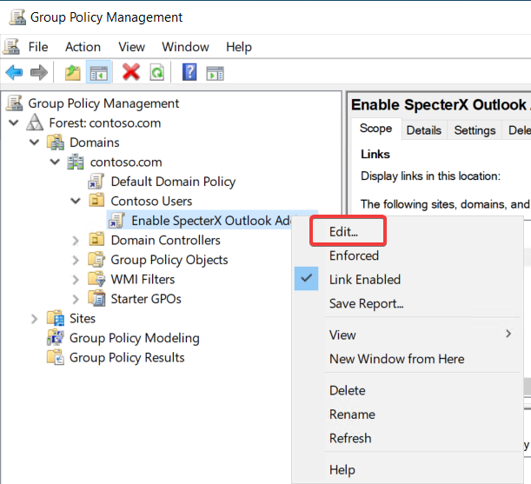

There are two options to control Outlook Add-in using group policy:
- Computer Configuration- will set the change for all the endpoints who inherits the group policy (and all the users using those machines)
- User Configuration- will set the change for all the users who inherit the group policy

This should be determined based on Microsoft group policy outlook add-in best practices.
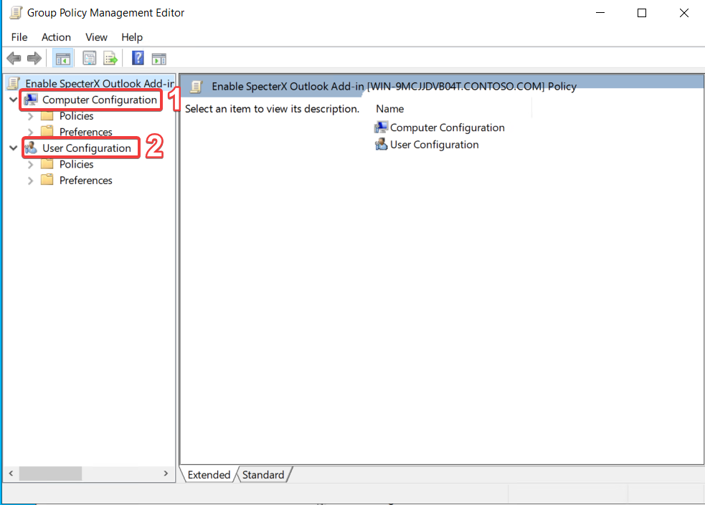

Scroll down to the appropriate path and create a new registry item
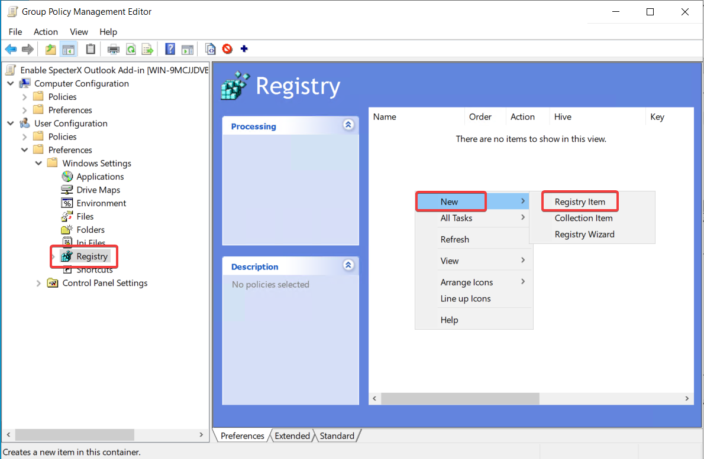

Use the following configuration to control (enable / disable) SpecterX outlook add-in:
Key Path: Software\Microsoft\Office\Outlook\Addins\SpecterX.Addin
Value Name: LoadBehavior
Value Data: REG_DWORD
- 00000002 - to disable the add-in
- 00000003 - to enable the add-in
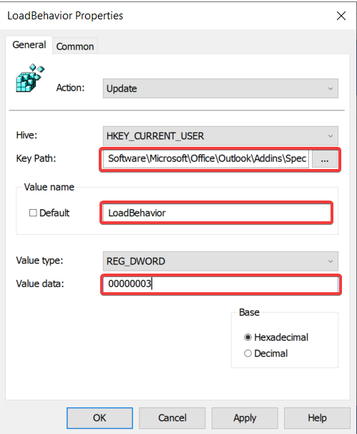

That’s it! You have successfully created a group policy that controls SpecterX add-in default behavior.

